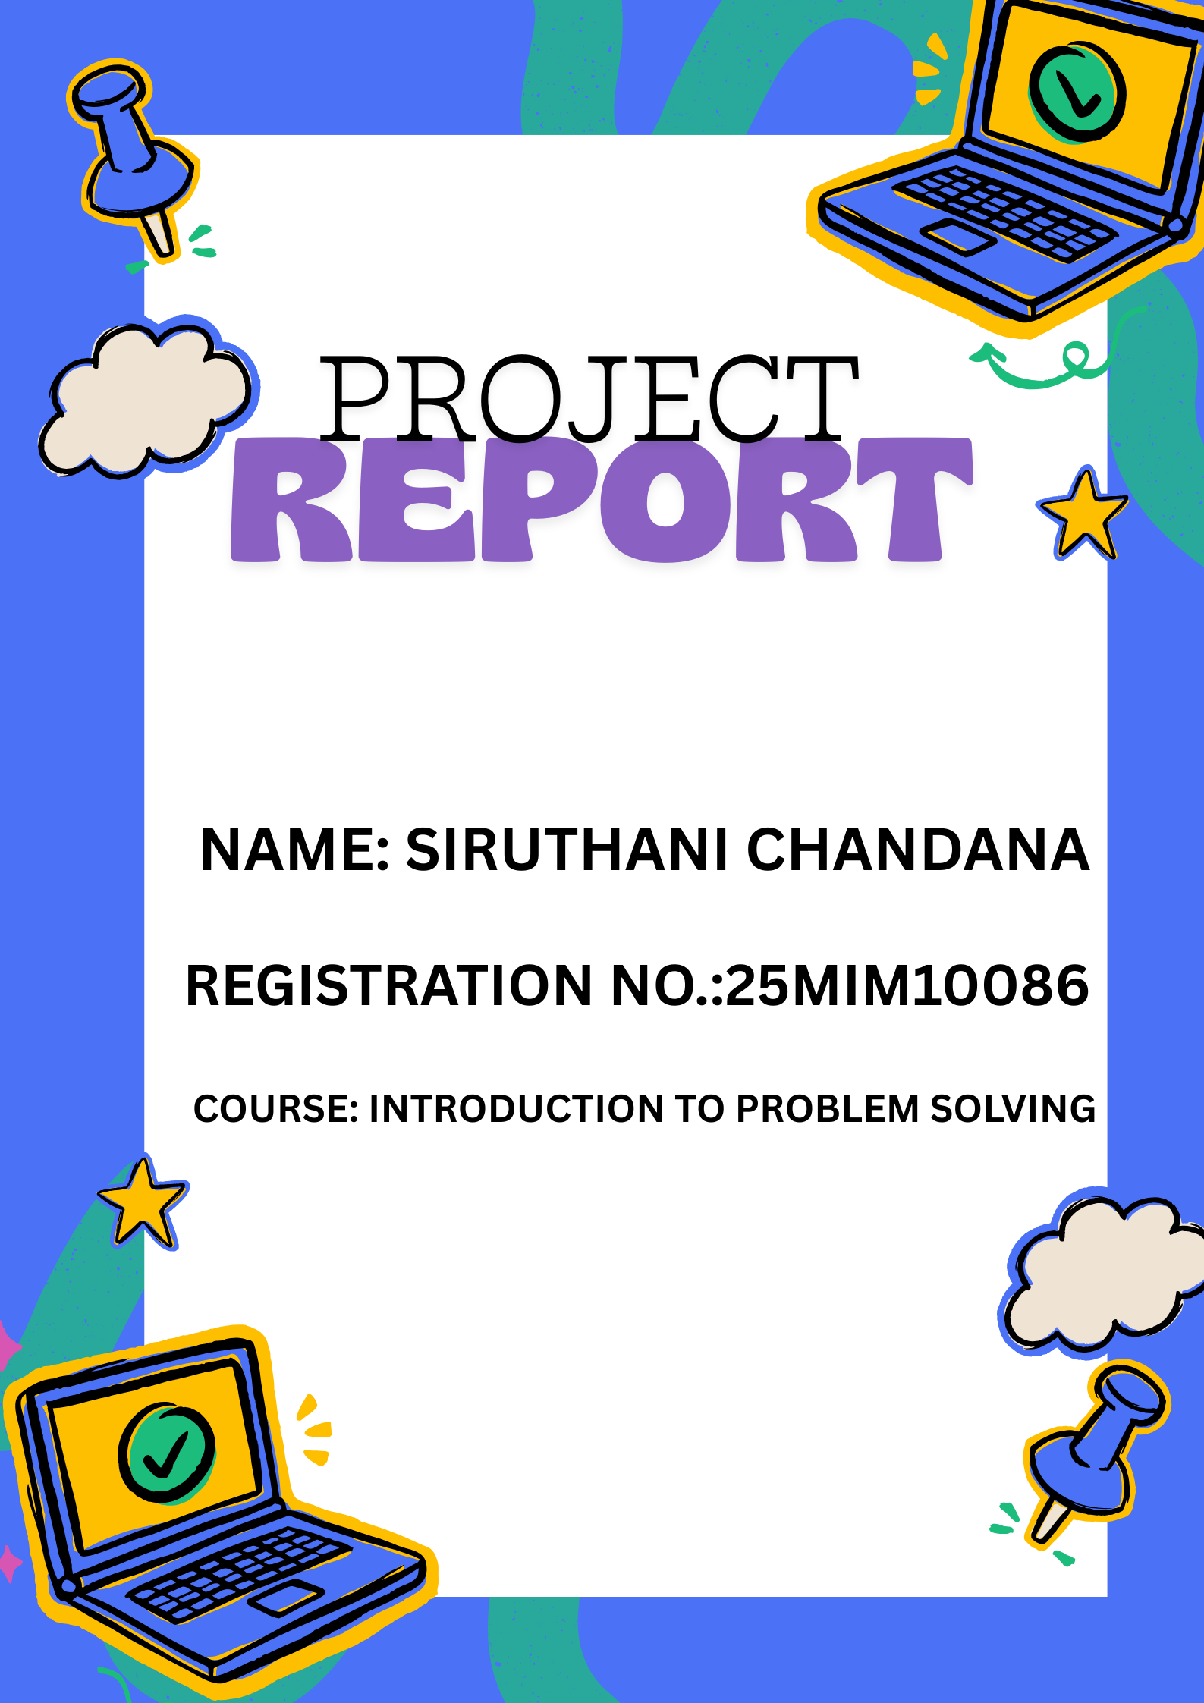

Introduction

The Number Guessing Game is a simple Python-based console application where the user attempts to guess a randomly generated number within a defined range. The project demonstrates basic programming concepts such as loops, conditional statements, exception handling, and random number generation. This mini-project is designed for beginners learning Python and helps to understand core logic flow in a program.

Problem Statement

To develop an interactive Python program that generates a random number and allows the user to guess it with feedback on whether the guess is too high, too low, or correct.

Functional Requirements

- The system must generate a random number within a predefined range.
- The user must be able to input guesses.
- The system must validate input and prevent invalid entries.
- The program must provide feedback on each guess.
- The system must count and display the number of attempts.
- The game should end when the user guesses correctly.

Non-functional Requirements

- Usability: Easy to understand and use.
- Performance: Response time should be minimal.
- Reliability: Error-free execution with proper input validation.
- Maintainability: Code must be readable and easy to modify.
- Portability: Should run on any device with Python installed.

System Architecture

User Input → Validation → Game Logic → Feedback → Result/Exit

Design Diagrams

🔹 Use Case Diagram
User ----> Guess Number ----> Get Result
🔹 Workflow Diagram
Start → Generate Random Number → User Guess → Compare → Correct? → Yes → End
↓
No → Repeat
🔹 Sequence Diagram
User → Program: Enter Guess
Program → System: Validate
System → Program: Compare Value
Program → User: Feedback
🔹 Class/Component Diagram
[Game]
- secret_number
- attempts
+ check_guess()
+ generate_number()
🔹 ER Diagram (Not Applicable)
Storage not used.

Design Decisions & Rationale

- Python was chosen due to its simplicity and readability.
- random module was used for generating unpredictable results.
- Input validation added to prevent program failure.

Implementation Details

- Language: Python 3.x
- Modules Used: random
- Program Type: Console-based interaction

Screenshots / Results
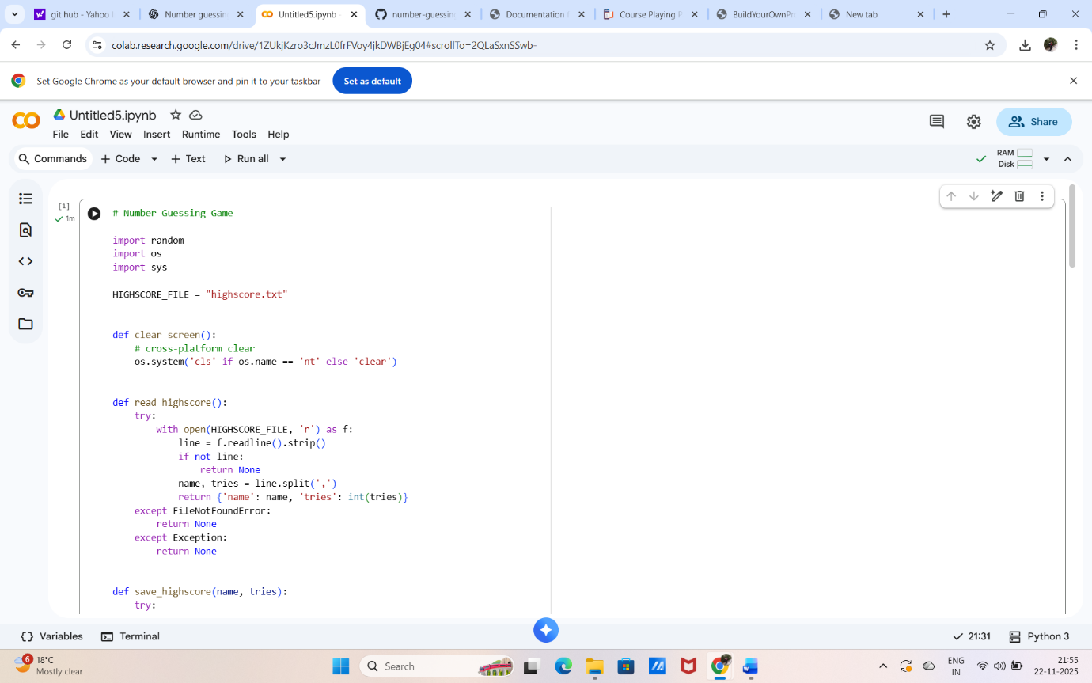
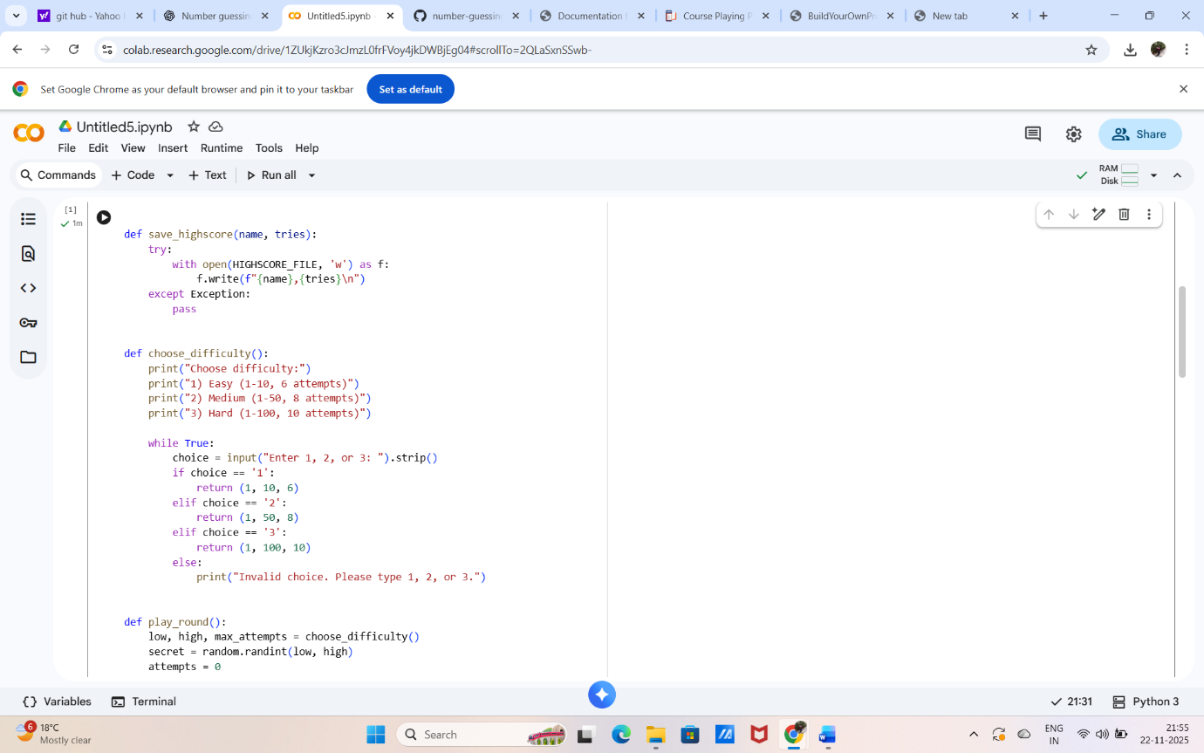
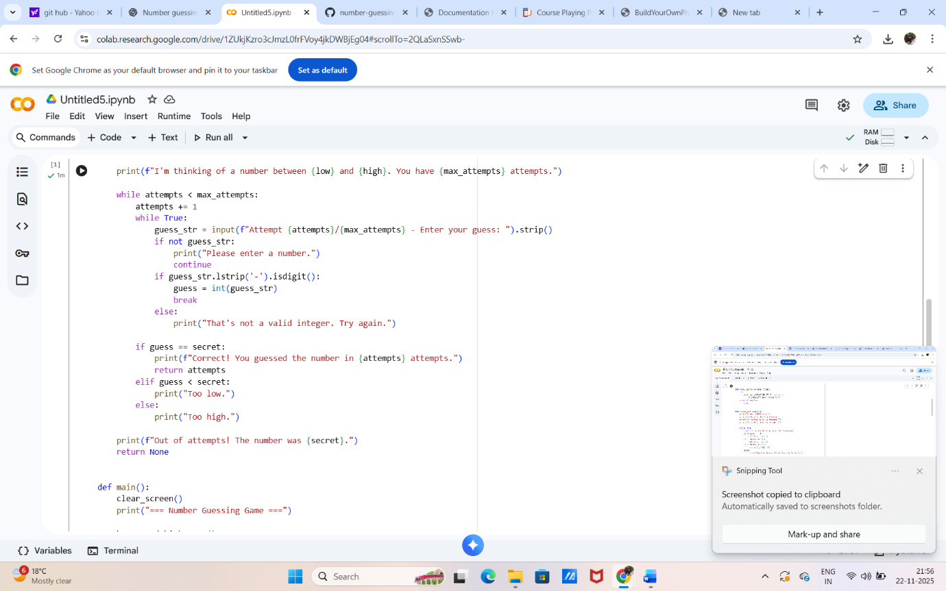
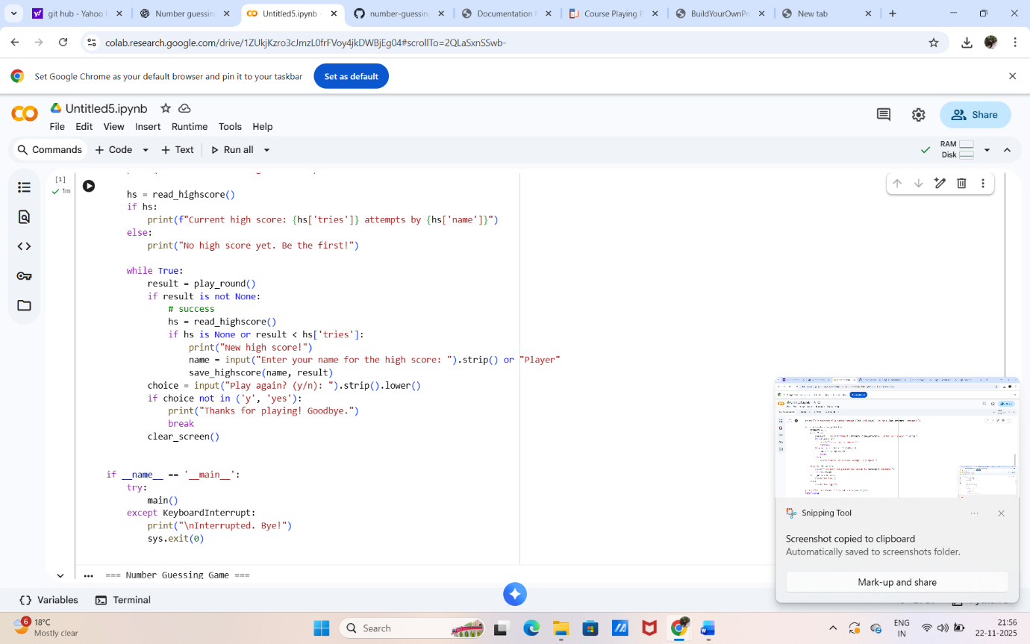
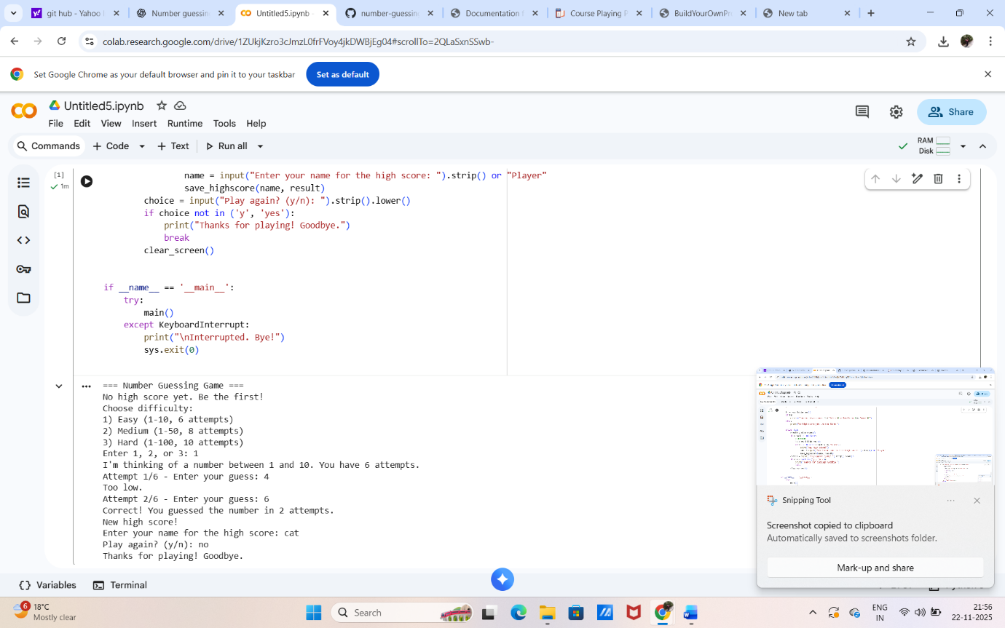

Testing Approach

- Manual testing was performed.
- Validation scenarios:
  - Alphabetic input → Error message displayed
  - Correct number → Program ends successfully
  - Out of range input → Accepted and processed

Challenges Faced

- Handling invalid inputs without crashing the program.
- Designing a user-friendly game flow.

Learnings & Key Takeaways

- Improved understanding of conditional logic.
- Learned importance of user input validation.
- Gained experience in writing clean and structured Python code.

Future Enhancements

- Add difficulty levels.
- Add high score tracking.
- Convert into a graphical game using Tkinter.
- Add multiplayer or timed mode.

